

|  |
| --- |
| CS 1103 - FR02B  Lab 5 |
| By Ngoc Phuong Anh Nguyen - 3712361  February 2021 |

# **Cleanup Exercise:**

## **1**. Customer Anne Farriss has called, asking for a listing of her invoice numbers and dates.

### Source code:

use Ch07_SaleCo;

select INV_NUMBER, INV_DATE from CUSTOMER natural join INVOICE where CUS_LNAME = "Farriss";

### Output:



Figure 1: Output result of Query 1

## 2. Corporate Management would like a list of all products sold by companies located in Florida.

### Source code:

select P_CODE, P_DESCRIPT from VENDOR natural join PRODUCT where V_STATE = "FL";



Figure 2: Output result of Query 2

## 3. Customer Anne Farriss called back and would like a complete account. This listing will need her name, phone number and balance, and invoice information

### Source code:

select*from CUSTOMER natural join INVOICE where CUS_LNAME = "Farriss";

### Output:



Figure 3: Output result of Query 3

# **Exercises:**

## 1. List all columns for the LGBrand table, ordered by BRAND_TYPE

### Source code:

use Ch07_LargeCo;

select*from LGBRAND order by BRAND_TYPE;

### Output:

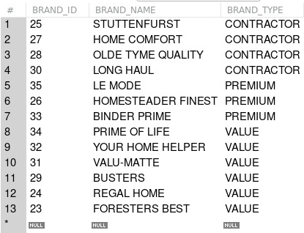

Figure 4: Output result of Query 1

## 2. For this same table, report the number of brands manufactured for each BRAND_TYPE. The columns should be renamed to more reasonable names.

### Source code:

select count(BRAND_NAME) as NUMBER_OF_BRAND, BRAND_TYPE from LGBRAND group by BRAND_TYPE;

### Output:

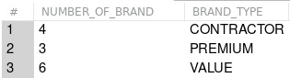

Figure 5: Output result of Query 2

## 3. List for each state the number of customers who have non-zero balances.

### Source code:

select CUST_STATE, count(CUST_CODE) as NUMBER_OF_CUSTOMER from LGCUSTOMER where CUST_BALANCE>0 group by CUST_STATE;

### Output:

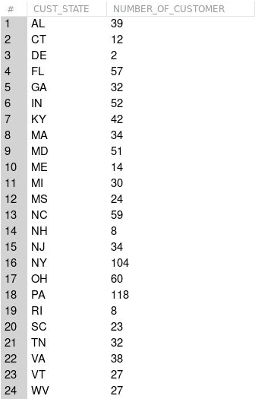

Figure 6: Output result of Query 3

## 4. For 3, show only states with more than 100 customers.

### Source code:

select CUST_STATE, count(CUST_CODE) as NUMBER_OF_CUSTOMER from LGCUSTOMER where CUST_BALANCE>0 group by CUST_STATE having count(CUST_CODE)>100;

### Output:

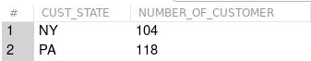

Figure 7: Output result of Query 4

## 5. For 4, order the output by State in reverse alphabetic order.

### Source code:

select CUST_STATE, count(CUST_CODE) as NUMBER_OF_CUSTOMER from LGCUSTOMER where CUST_BALANCE>0 group by CUST_STATE having count(CUST_CODE)>100 order by CUST_STATE desc;

### Output:

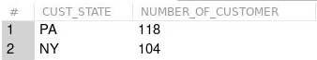

Figure 8: Output result of Query 5

## 6. For 3, show only states with more than 100 customers, ordered by number of customers (fewest first).

### Source code:

select CUST_STATE, count(CUST_CODE) as NUMBER_OF_CUSTOMER from LGCUSTOMER where CUST_BALANCE>0 group by CUST_STATE having count(CUST_CODE)>100 order by NUMBER_OF_CUSTOMER asc;

### Output:

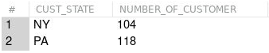

Figure 9: Output result of Query 6

## 7. List the number of products purchased for each Brand Type, in the State of Maine (‘ME’)

### Source code:

select LB.BRAND_TYPE, sum(LP.PROD_QOH) from LGBRAND as LB, LGPRODUCT as LP, LGCUSTOMER as LC where LB.BRAND_ID = LP.Brand_ID and LC.CUST_STATE = "ME" group by LB.BRAND_TYPE;

### Output:

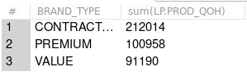

Figure 10: Output result of Query 7

## 9. Who is the newest employee and how long have they been with the company? List only the one employee.

### Source code:

select max(EMP_HIREDATE), EMP_FNAME, EMP_LNAME from LGEMPLOYEE;

### Output:



Figure 11: Output result of Query 9